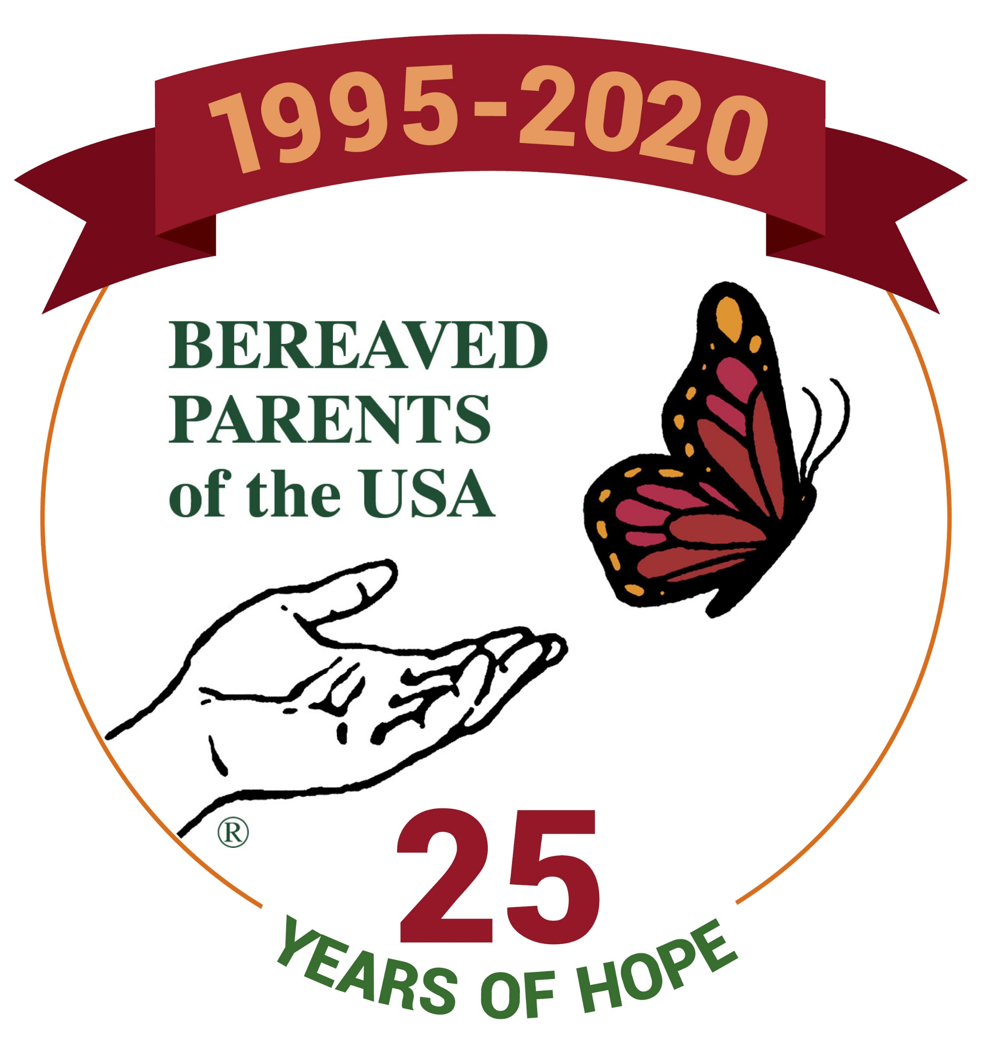
BPUSA GATHERING CONFERENCE
WORKSHOP PRESENTER APPLICATION
Deadline to submit application is March 1, 2020

For questions regarding the application process contact:

Melanie E. Groves
BPUSAGatheringChair@gmail.com
304-612-1341

25th Anniversary of BPUSA
August 7-9, 2020
St. Louis, MO
Sheraton Clayton Plaza Hotel
7730 Bonhomme Ave.
St. Louis, MO 63105

I will be available to present my workshop and/or repeat my workshop at any of following sessions:

Friday € A.M. € P.M. Saturday € A.M. € P.M. € I am willing to repeat workshop

Are you willing to facilitate a Sharing Session? € Friday Night € Saturday Night

The Gathering Conference Committee will try to accommodate all session requests, but we may need to change the schedule because of cancellations and other unexpected disruptions.

Submit application online at https://bereavedparentsusa.org/gathering-home/
(preferred method)
or
Print this application and mail to:
Melanie E. Groves
1190 Worthington Drive
Bridgeport, WV 26330

(Please fill in all categories that apply to you, not just the one you would speak about)

I am a... € Bereaved Parent € Bereaved Sibling € Bereaved Grandparent € Professional € Other

If applicable, please provide information for up to two children/siblings/grandchildren.
If there are more, please attach an additional document.

First and last name of child/sibling/grandchild: __________________________________________________________

Date of Birth _______________ Date of Death ________________ Cause of Death ____________________________

First and last name of child/sibling/grandchild: __________________________________________________________

Date of Birth _______________ Date of Death ________________ Cause of Death ____________________________
IMPORTANT NOTES:
- Workshop presenters must register for the Gathering Conference and pay a reduced registration fee of $50. Bereaved Parents of the USA does not provide speaker fees or compensation for workshop presenters.
- Workshop presenters will be notified of acceptance by April 1, 2020. The Gathering Conference Committee will try to accommodate all session requests. However, the actual day and time that your workshop is scheduled may not yet be available at that time. If you need your presentation to be scheduled on a certain day or time, please provide details of the circumstances and we will do our best to accommodate your request.
- Please be aware that we may need to edit the information you provide below in the interest of brevity or clarity.
- If you are the author of a book for sale, please contact Janet at Centering Corporation to inquire about having your book made available in the Gathering Bookstore. You can reach Janet at 402-553-1200.
- If you have a book, we ask that you don’t make repeated references to it or read from it during your workshop. Past attendee evaluations have indicated a negative reaction when authors refer repeatedly to their books in the workshop setting. Instead, please mention it at the beginning of the workshop, and let the group know if it is available at the Gathering Bookstore.

Name: ___________________________________________ Email: _______________________________________
Address: ______________________________________________________________________________________
Home Phone: _(________)_______________________ Cell Phone: _(_______)_____________________________

Your Bio
In a short paragraph (e.g., 4-5 sentences), please provide your bio including information about your grief experience and other credentials. We will use this paragraph in the Gathering Program.
We reserve the right to edit the paragraph to fit within the constraints of the Gathering Program.

Signature: _________________________________________________ Date:________________________
This section is to give the workshop committee an idea of what your workshop is about and the information you will be presenting to the attendees. The structure portion is particularly important to the committee. Each workshop presentation will be 50 minutes in length including Q & A.

Preferred title of workshop:

Workshop topic:

Basic structure of workshop with specifics

Brief Description of Workshop to be placed in the Gathering Program.

Handouts - Attendees appreciate handouts. Plan for a minimum of 30 handouts per workshop.

Special requests for room set up, i.e. Classroom, Theater, Circle, etc.

Important A/V note: If possible, please bring your own computer and A/V equipment that your workshop requires. BPUSA cannot guarantee equipment for all presenters because there are so many workshops going on at the same time. However, if you are unable to furnish equipment that you need, BPUSA will try to accommodate requests. Please clearly indicate your needs by checking any of the following statements that apply to you:
€ I need a room with a screen € I will provide my own projector € I need a projector
**If you have a computer but need a projector please note that you will need to bring a VGA or HDMI converter.
Other request(s)?

