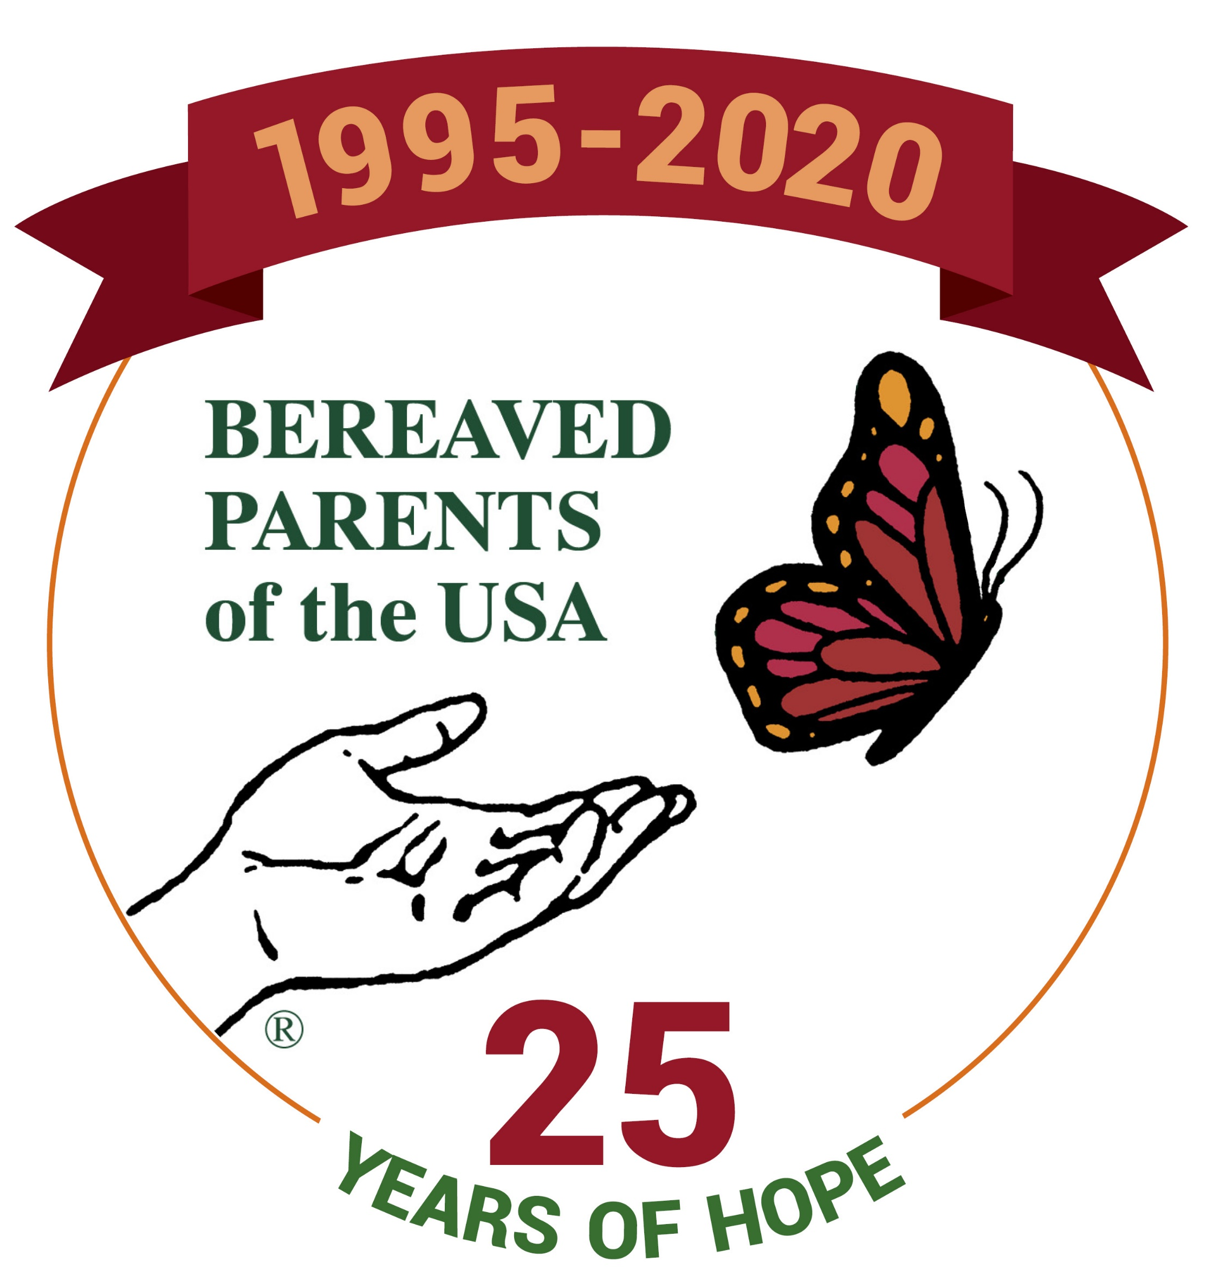
Name: ___________________________________________ Email: _______________________________________
Address: ______________________________________________________________________________________
Home Phone: _(________)_______________________ Cell Phone: _(_______)_____________________________

(Please fill in all categories that apply to you, not just the one you would speak about)

I am a... € Bereaved Parent € Bereaved Sibling € Bereaved Grandparent

Please provide the following information. If necessary, attach an additional page.

First and last name of child/sibling/grandchild: ______________________________________________________

Date of Birth _______________ Date of Death ________________ Cause of Death ________________________

First and last name of child/sibling/grandchild: ______________________________________________________

Date of Birth _______________ Date of Death ________________ Cause of Death ________________________
BPUSA GATHERING CONFERENCE SPEAKER APPLICATION
Deadline to submit application is October 1, 2019

IMPORTANT NOTES:
- Notification of speaker acceptance will begin in November. However, the actual day and time that a speaker is scheduled may not be available at that time. If you need your presentation to be scheduled on a certain day or time, please provide details of the circumstances and we will attempt to accommodate your request.
- Please be aware that we may need to edit the information you provide below in the interest of brevity or clarity.
- If you are the author of a book for sale, please contact Janet at Centering Corporation to inquire about having your book made available in the Gathering Bookstore. You can reach Janet at 402-553-1200.
- If you have a book, we ask that you don’t make repeated references to it or read from it while speaking. Past attendee evaluations have indicated a negative reaction when authors refer repeatedly to their books during the keynote. Instead, please mention it at the beginning of your address, and tell the audience that it is available at the Gathering Bookstore.
- If you have video of prior speaking engagements, please send a file or link along with your application.
- Please provide a current photo to use in the event you are chosen to be one of our speakers.
- All speakers are expected to do a minimum of one workshop and attend the entire Gathering Conference in order to be available to our Gathering attendees.
- The speaker’s registration fee, weekend meal plan, and two nights in the hotel are provided by the Gathering Conference Committee. (Please register for the Gathering Conference for our record-keeping.)
I will be available to speak at the following times:
Friday € Lunch € Dinner Saturday € Breakfast € Lunch

The Committee will try to accommodate your request but may need to change the schedule in the case of unforeseen circumstances.

25th Anniversary of BPUSA
August 7-9, 2020
St. Louis, MO
Sheraton Clayton Plaza Hotel
7730 Bonhomme Ave.
St. Louis, MO 63105

Submit application online at
https://bereavedparentsusa.org/gathering-home/
(preferred method)
or
Print this application and mail to:
Melanie E. Groves
1190 Worthington Drive
Bridgeport, WV 26330

For questions regarding the application process contact

Melanie E. Groves
BPUSAGatheringChair@gmail.com
304-612-1341

Signature: _________________________________________________________ Date: ____________________
This section is to give the Gathering Conference Committee an idea of what your talk is about and the information you will be presenting to the attendees. The structure portion is particularly important to the Gathering Conference Committee.

Presentations must be at least 20 minutes in length, and not longer than 30 minutes.

Preferred Title of Talk: ________________________________________________________________

Talk Topic: __________________________________________________________________________

Basic structure of your talk with specifics:

How might attendees apply what they learned from you?

BPUSA will provide a microphone for your presentation. Do you need additional A/V Equipment? € Yes € No

If yes, please indicate specific needs:
€ additional microphone(s), wired only € projector € screen € audio (i.e. playing music)

YOUR GRIEF BIO:
In 4-5 sentences, please tell us about your grief experience and other credentials and how they relate to your talk. Include information on prior speaking engagements – keynotes, addresses for bereavement groups or chapters, other presentations – and the topic(s) on which you spoke. The committee will use this information as your bio in the Gathering program booklet.

